CAS PY 106

Prelecture Note 19

1. Flux
2. The word flux has various meanings
3. Our focus is a quantity expressing the strength of a field of force in a given area
4. Flux – measure of the number of field lines passing through an area
5. Magnetic Flux
6. Magnetic flux is measure of number of magnetic field lines passing through an area
7. Defining the area of the loop as a vector, with its direction perpendicular to the plane of the loop, the magnetic flux is given by

O = BAcos(theta)

Where B is magnetic field and A is area

Theta is the angle between the magnetic field and the area vector

1. Unit of magnetic flux is the weber (1Wb = 1T\*m^2)
2. The more field lines passing through an area, the larger the flux
3. Lots of Flux

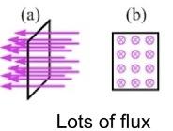

1. No Flux

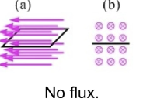

1. Some Flux

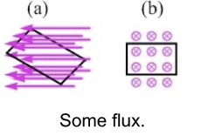

1. Faraday’s Law
2. Volltage induced in coil of N turns is given by the rate of change of the magnetic flux in the coil:
3. Faraday’s Law:

e = -N\* (delta O) / (delta t)

e = emf or voltage

1. Incredible number of practical applications, particularly in generation and distribution of electricity
2. Call the voltage induced by changing magnetic flux an induced emf
3. This is because changing magnetic flux acts like a battery in a coil or loop, which is why there is a current when there’s complete circuit
4. Faraday’s Law:

e = -N\* (delta O) / (delta t)

e = -N \* (delta BAcos(theta)) / (delta t)

1. The minus sign in Faraday’s Law has to do with the fact that, if there is a complete circuit, the induced voltage sets up current that creates magnetic field that opposes the change in magnetic flux
2. Three main ways to generate a voltage using a magnetic field:

* Change the field (such as by moving a magnet around near a loop of wire)
* Change the area (squeeze the loop to change the shape)
* Change the orientation of the loop with respect to the field (spin the loop)